SELECTION PROCESS FOR THE BOARD OF
COMMISSIONERS OF IRISH LIGHTS
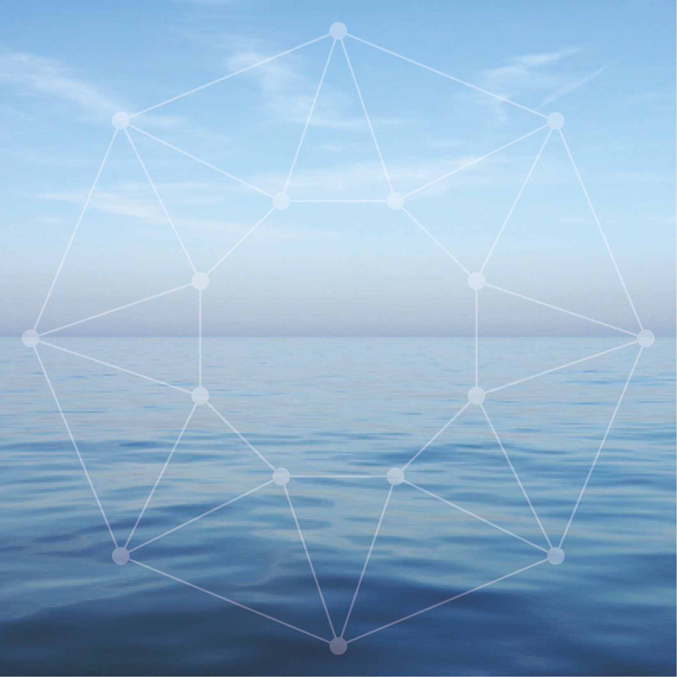

Head Office Location: Harbour Road, Dun Laoghaire, Co Dublin, A96 H500

Board Activity: There are generally eight ordinary Board meetings annually. From time to time these may be supplemented and/or merged with a Board workshop. The majority of meetings take place in Dun Laoghaire with one or two each year outside of Dublin. There are 3 standing Board sub-committees, Audit & Risk, Nominations, Remuneration. From time to time special purpose sub- committees are established.

Board members normally participate in a short (3 day) ‘Working
Inspection’ on the Granuaile every twelve to eighteen months.
The purpose of the Working Inspection is to review the ongoing
programme of capital investment on the coast and to review the
impact of future or agreed policies on navigation, marine safety and
property management.

Main Governing Legislation: Merchant Shipping Act 1894 applicable in the Republic of Ireland and UK Merchant Shipping Act 1995 for Northern Ireland.

Registered Charity: Irish Lights has a charitable exemption from the Revenue Commissioners (CHY no. 1979) and is registered with the Charities Regulatory Authority (No 20002794). Board Members must be able to meet the Trustee requirements of section 55 (1) of the Charities Act 2009

Funding & Governance: Irish Lights is funded via the General Lighthouse Fund (GLF) which is administered by the Department of Transport (UK). Irish Lights funding sources include: light dues collected in Ireland, a GLF contribution for Northern Ireland, funds from commercial activities and a contribution from the Department of Transport Tourism and Sport (IRL). Irish Lights meets the reporting and compliance requirements laid down by the Department of Transport for the GLF. It also meets the requirements set out in UK and Irish Governance Codes for Statutory Bodies.

Scale of Organisation: Approximately 120 employees and budget of circa €15m

Remuneration: Board members do not receive any fees for their services.

Background
The mission of Irish Lights is Safe Navigation at Sea. We are a maritime organisation delivering essential 24/7 safety and navigation services around the coast of Ireland (north and south), 365 days a year. Our vision is to protect lives, property, trade and the environment by delivering next generation maritime services at the interface of navigation technology, engineering and data management.
Irish Lights is responsible for Maritime Aids to Navigation (AtoN) under the Safety of Life at Sea (SOLAS) Convention. This remit includes the provision and maintenance of over 330 general aids to navigation, the superintendence of approx. 3,300 local aids to navigation, and marking or removing dangerous wrecks outside harbour areas around Ireland.
Irish Lights also provides a range of navigation and contract commercial services including ship charter, buoy services, equipment hosting and maritime data. We provide value added services to support the development of the broader maritime economy including Met and Coastal Data Services. The Irish Lights tourism and heritage initiative, the ‘Great Lighthouses of Ireland' was developed in partnership with local communities and offers visitors from home and abroad the chance to visit or stay in a working lighthouse.
Irish Lights is vested under Section 634 of the Merchant Shipping Act 1894 with the responsibility for superintendence and management of all lighthouses and other AtoN in respect of Ireland and the adjacent seas and islands. The Merchant Shipping Act 1995 Section 195 (1) empowers Irish Lights with the same function for Northern Ireland. Irish Lights also has responsibility for the marking and removal of wrecks in Ireland under the Merchant Shipping (Salvage and Wreck) Act 1993 Part IV and for Northern Ireland authority is vested in Irish Lights under the Merchant Shipping Act 1995.
Irish Lights is responsible for meeting the Irish and British Governments’ responsibilities under Chapter V Regulation 13 of the International Maritime Organization’s, Safety of Life at Sea (SOLAS) Convention.

Strategic Direction
The current Irish Lights strategy for the period 2018-2023 “Safe Seas – Connected Coasts” was launched in April 2018. As the provider of General Aids to Navigation around the island of Ireland (north and south), Irish Lights has a long and respected track record of service to the maritime community dating back to 1786. In more recent times, the context in which that service must be delivered has changed. This is due to rapid technological advances, pressures on the marine and coastal environment and more diverse stakeholder needs, requiring a greater emphasis on collaboration across agencies and with international organisations. This creates both opportunities and challenges, which are proactively addressed in our 5 year strategy. The strategy recognises the exciting and challenging trends in the maritime sector at national and international level. It places a strong emphasis on positioning Irish Lights to play a leadership role in the delivery of next generation navigation and safety services, enabled by innovation and technology.

Recent Performance
Over the period of its last strategy 2012 -2017, Irish Lights has embraced substantial change with running costs reducing by €3.3m (21%) since 2012 (following on from a reduction of €5.7m. in the previous 4 years) and a broadening of commercial activities up 100% on starting levels. In terms of operational performance we delivered consistent year on year high standards of AtoN availability exceeding international standards. We continued to introduce new technology using the latest light source and solarisation technology, improving services and reducing costs. Our coastal network was enhanced with new monitoring and communications upgrades. Our local aids service was strengthened and stakeholder engagement intensified. A trial MetOcean service was established to deliver real time weather observations to enhance safety information for a wide range of maritime users. A new all island, lighthouse tourism brand was launched across 12 sites, financed largely by European Union grant aid which has resulted in 140,000 visitors to lighthouses in 2017 and 19,000 available bed nights in lighthouse accommodation.

Irish Lights Board
- Functions of the Board
The function of the Board is to decide on policy and strategy for the organisation and oversee its implementation, ensuring that high standards of governance are met.

- Composition and Terms
The Board has due regard for the benefits of diversity, experience and expertise and strives to achieve the right balance in its goal to provide leadership, effectiveness, accountability and sustainability to Irish Lights.
The Board consists of:
- Co-opted Commissioners.
- The Lord Mayor of the city of Dublin plus three Councillors’ of the City of Dublin (ex officio Commissioners).
- The Chief Executive in her capacity as Accounting Officer is a member of the Board with no voting rights.

Irish Lights considers all Commissioners to be non-executive, independent Directors. A Register of Interests that includes details of company directorships or other significant interests held by Board members is maintained.

New Board members are appointed for a 5 year term with the possibility of a renewal for another 5 years. The Lord Mayor and ex officio members are appointed as Board members for as long as they hold such office.

- New Board Member - Person Specification

Applications are invited from suitably qualified candidates for up to 3 vacancies on the Board of Commissioners of Irish Lights. Applicants should have Board / Management experience together with commercial or public sector experience and/or an interest in the marine sector. Specific capability in one or more of the following areas is also sought:
- Financial Management with a professional accounting qualification
- Legal
- Heritage / Tourism
- Marketing and Communications
- Human Resources and /or Change Management
In addition to the above, standard eligibility requirements for public office / charity trustee will apply.

- Term of Appointment
Appointment to the Board will be for a period of 5 years with the possibility of an extension of another term of 5 years, subject to the following:

- The membership of any member of the Board may be terminated by the Chairman at any time, on the basis of reasons to be stated by the Chairman.
- A member of the Board may at any time resign his or her membership by notice in writing sent or given to the Chairman of the Board, and the resignation shall take effect on the date specified in the letter or the date the letter is received, whichever is the later.

- Submitting your Expression of Interest
If you are interested in a Board position, please complete the application form, which can be found in Appendix 1. You should consider carefully how your background and experience fits in with the specific appointment criteria set out in the Person Specification above. Please give careful consideration to the possibility of any potential conflict of interest that may arise if appointed to the Board.
You should address your completed application form, curriculum vitae, cover letter and any supplementary information marked Private and Confidential to the Chairman, Commissioners of Irish Lights, Harbour Road, Dun Laoghaire or to Boardappointments@irishlights.ie by 25th September 2018.

- Assessment Process

A Nominations Committee will be convened to consider and assess the expressions of interest received by Irish Lights. The Committee will:

- Review and discuss the expressions of interest received against the specific appointment criteria for the role, as advertised in this Information Booklet;

- Assess potential candidates further once they meet the specified appointment criteria by undertaking any or all of the following steps:
  - Consideration of the written applications; and/or
  - Interview; and/or
  - Referee checks; and/or
  - Any other selection or verification method deemed appropriate.

- Shortlist candidates will be contacted after 28th September, 2018.

- Interview if appropriate will take place on 19th October, 2018 in the Irish Lights Head Office in Dun Laoghaire.

- The Nominations Committee will make a recommendation to the Board for their approval.

- Following approval from the Board, the approval of the Department of An Taoiseach will be sought.

- Confidentiality

Applications will be treated in the strictest confidence. All enquires, applications and all aspects of the proceedings are treated as strictly confidential and are not disclosed to anyone, outside of those directly involved in that aspect of the process.

APPENDIX 1
NOTICE OF CANDIDATURE FOR APPOINTMENT TO BOARD OF IRISH LIGHTS
Name:
Address:
Telephone number: |  |  | Mobile:
Educational and Professional Qualifications:
Details of Board / Management Experience (please specify):
Details of experience/interest in Marine Sector:
Details of qualifications and or capability in one or more of the following fields:
- Financial Management with a professional accounting qualification
- Legal
- Heritage / Tourism
- Marketing and Communications
- Human Resources
Other experience which could benefit Commissioners of Irish Lights:
I wish to be considered for appointment to the Board of Commissioners of Irish Lights:

Signed:
Date:
You must submit your curriculum vitae, cover letter and any other supplementary information with the completed application form.
Please return the completed application form by 25th September 2018 marked Private and Confidential to the Chairman, Commissioners of Irish Lights, Harbour Road, Dun Laoghaire or to Boardappointments@irishlights.ie

If you have any queries about the application form or process you can contact Robert Hudson,
HR Manager, robert.hudson@irishlights.ie

Privacy Notice

By submitting this application to Irish Lights you are consenting to the provision of your personal data for use by Irish Lights. The data you provide will be used by authorised personnel for the purposes of Board Selection only. The legal basis for processing this data under Data Protection Legislation is Consent.

The data you provide will be held in accordance with the Irish Lights Retention & Disposal Policy and will be destroyed 3 months after this process closes. Irish Lights will not use your personal data for direct marketing purposes and your data will not be subject to profiling or automated decision making. This data will not be shared with an external third party. This data will not be shared with an external third party.

For more information please refer to the Irish Lights Privacy Statement on our website http://www.irishlights.ie/terms.aspx#dataprotection or contact the Data Protection Officer at DPO@irishlights.ie

