SELECTION PROCESS FOR THE BOARD OF THE
COMMISSIONERS OF IRISH LIGHTS
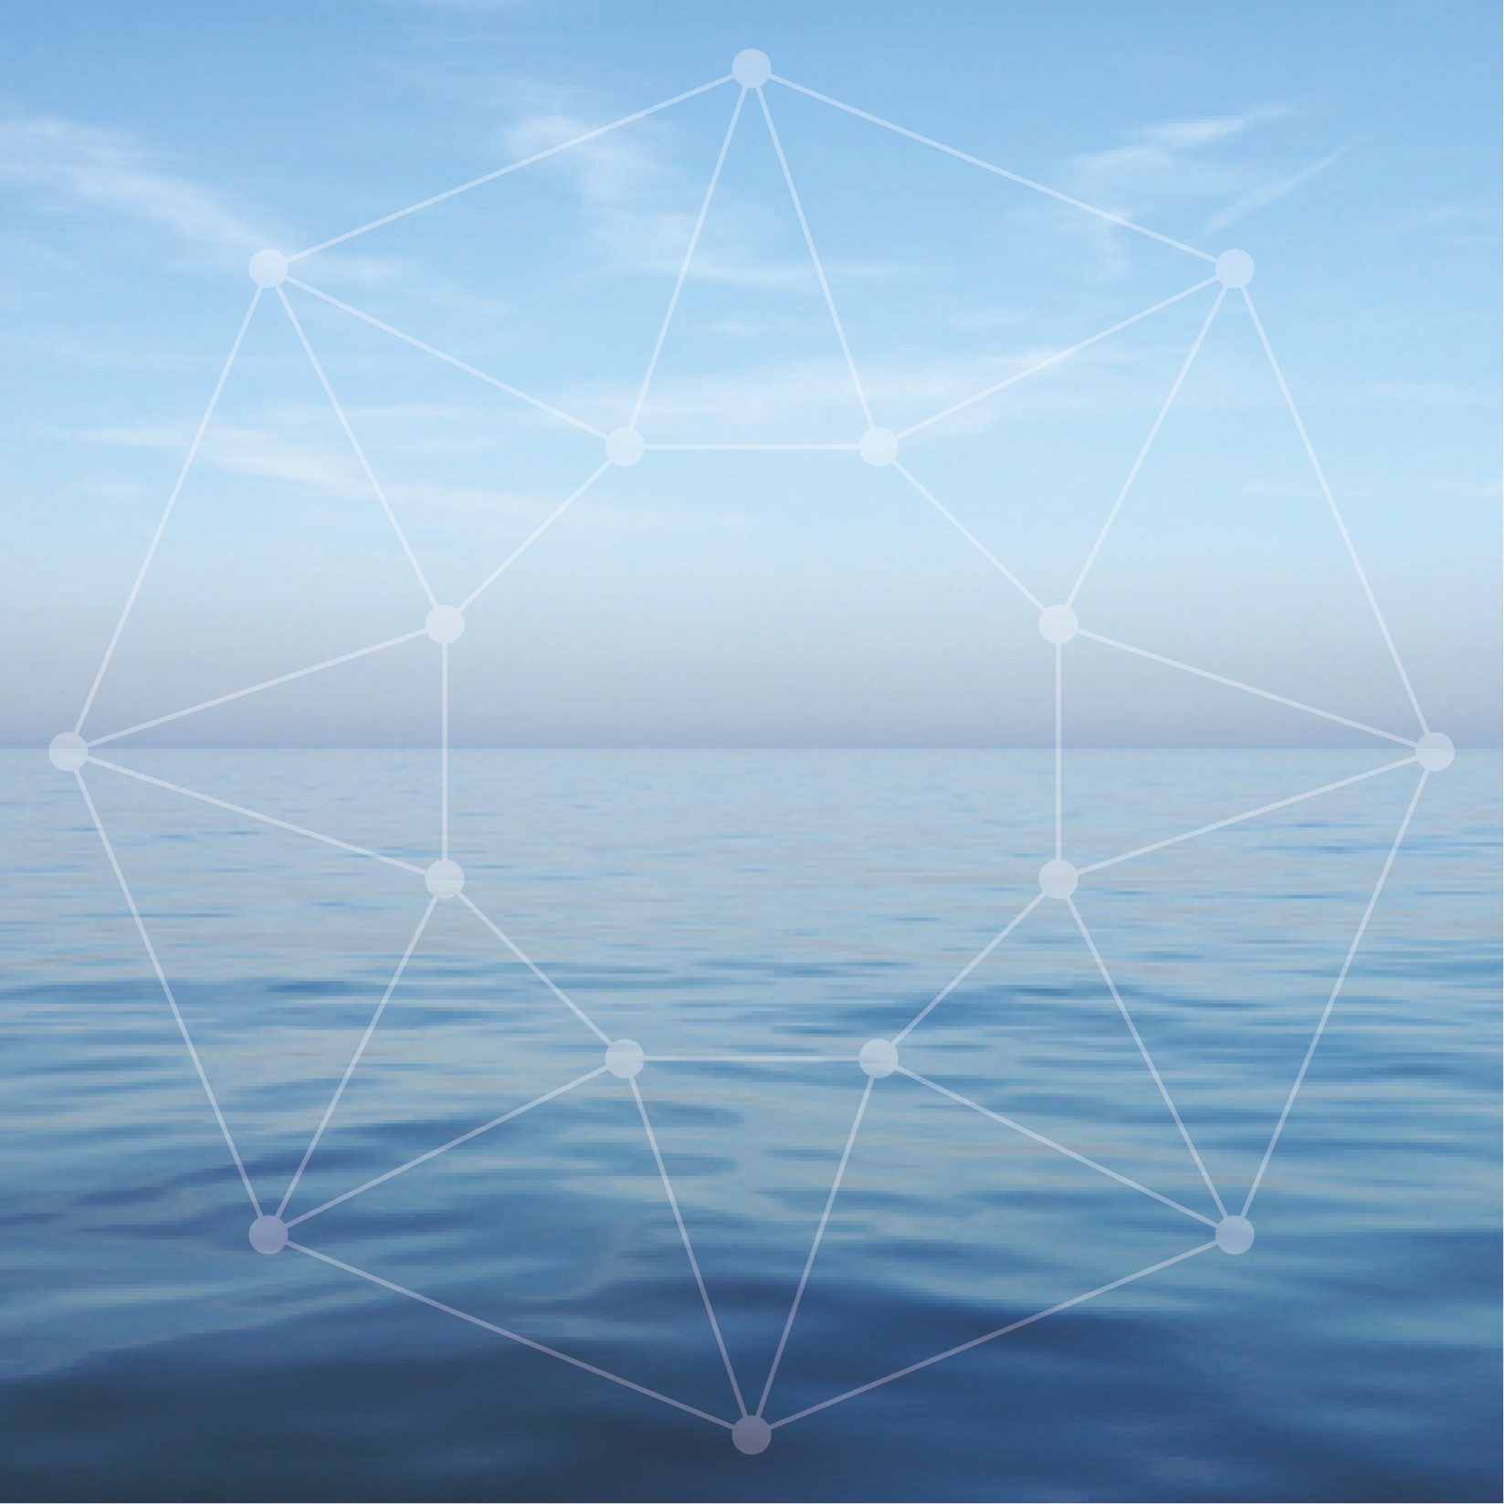

Head Office Location: Harbour Road, Dun Laoghaire, Co Dublin, A96 H500

Board Activity: There are generally eight ordinary Board meetings annually. From time to time these may be supplemented and/or merged with a Board workshop. The majority of meetings take place in Dun Laoghaire with one or two each year outside of Dublin. There are 3 standing Board sub-committees, Audit & Risk, Nominations, Remuneration. From time to time special purpose sub- committees are established.

Board members normally participate in a short (3 day) ‘Working
Inspection’ on the Granuaile every twelve to eighteen months.
The purpose of the Working Inspection is to review the ongoing
programme of capital investment on the coast and to review the
impact of future or agreed policies on navigation, marine safety and
property management.

Main Governing Legislation: Merchant Shipping Act 1894 applicable in the Republic of Ireland and UK Merchant Shipping Act 1995 for Northern Ireland.

Registered Charity: Irish Lights has a charitable exemption from the Revenue Commissioners (CHY no. 1979) and is registered with the Charities Regulatory Authority (No 20002794). Board Members must be able to meet the Trustee requirements of section 55 (1) of the Charities Act 2009

Funding & Governance: Irish Lights is funded via the General Lighthouse Fund (GLF) which is administered by the Department of Transport (UK). Irish Lights funding sources include: light dues collected in Ireland, a GLF contribution for Northern Ireland, funds from commercial activities and a contribution from the Department of Transport (IRL). Irish Lights meets the reporting and compliance requirements laid down by the Department for Transport (UK) for the GLF. It also meets the requirements set out in UK and Irish Governance Codes for Statutory Bodies.

Scale of Organisation: Approximately 125 employees and budget of circa €18m

Remuneration: Board members do not receive any fees for their services.

Background
The mission of Irish Lights is Safe Navigation at Sea. We are a maritime organisation delivering essential 24/7 safety and navigation services around the coast of Ireland (north and south), 365 days a year. Our vision is to protect lives, property, trade and the environment by delivering next generation maritime services at the interface of navigation technology, engineering and data management.
Irish Lights is responsible for Maritime Aids to Navigation (AtoN) under the Safety of Life at Sea (SOLAS) Convention. This remit includes the provision and maintenance of over 330 general aids to navigation, the superintendence of approx. 3,300 local aids to navigation, and marking or removing dangerous wrecks outside harbour areas around Ireland.
Irish Lights also provides a range of navigation and contract commercial services including ship charter, buoy services, equipment hosting and maritime data. We provide value added services to support the development of the broader maritime economy including Met and Coastal Data Services. The Irish Lights tourism and heritage initiative, the ‘Great Lighthouses of Ireland' was developed in partnership with local communities and offers visitors from home and abroad the chance to visit or stay in a working lighthouse.
Irish Lights is vested under Section 634 of the Merchant Shipping Act 1894 with the responsibility for superintendence and management of all lighthouses and other AtoN in respect of Ireland and the adjacent seas and islands. The Merchant Shipping Act 1995 Section 195 (1) empowers Irish Lights with the same function for Northern Ireland. Irish Lights also has responsibility for the marking and removal of wrecks in Ireland under the Merchant Shipping (Salvage and Wreck) Act 1993 Part IV and for Northern Ireland authority is vested in Irish Lights under the Merchant Shipping Act 1995.
Irish Lights is responsible for meeting the Irish and British Governments’ responsibilities under Chapter V Regulation 13 of the International Maritime Organization’s, Safety of Life at Sea (SOLAS) Convention.

Strategic Direction
The current Irish Lights strategy for the period 2018-2023 “Safe Seas – Connected Coasts” was launched in April 2018. As the provider of General Aids to Navigation around the island of Ireland (north and south), Irish Lights has a long and respected track record of service to the maritime community dating back to 1786. In more recent times, the context in which that service must be delivered has changed. This is due to rapid technological advances, pressures on the marine and coastal environment and more diverse stakeholder needs, requiring a greater emphasis on collaboration across agencies and with international organisations. This creates both opportunities and challenges, which are proactively addressed in our 5 year strategy. The strategy recognises the exciting and challenging trends in the maritime sector at national and international level. It places a strong emphasis on ensuring that Irish Lights can play a leadership role in the delivery of next generation navigation and safety services, enabled by innovation and technology.

Irish Lights Board
- Functions of the Board
The function of the Board is to decide on policy and strategy for the organisation and oversee its’ implementation, ensuring that high standards of governance are met.

- Composition and Terms
The Board has due regard for the benefits of diversity, experience and expertise and strives to achieve the right balance in its goal to provide leadership, effectiveness, accountability and sustainability to Irish Lights.
The Board consists of:
- Co-opted Commissioners.
- The Lord Mayor of the city of Dublin plus three Councillors’ of the City of Dublin (ex officio Commissioners).
- The Chief Executive in her capacity as Accounting Officer is a member of the Board with no voting rights.

Irish Lights considers all Commissioners to be non-executive, independent Directors. A Register of Interests that includes details of company directorships or other significant interests held by Board members is maintained.

New Board members are appointed for a 5 year term with the possibility of a renewal for another 5 years. The Lord Mayor and ex officio members are appointed as Board members for as long as they hold such office.

- New Board Member - Person Specification

We are looking for 4 experienced individuals to join our Board, to support the ongoing development of the organisation. Two appointments will be made in the first quarter of 2023, with a further two appointments later in 2023. Applicants should have Board / Senior Management experience and a specific capability in one or more of the following;
- Financial experience and expertise – an Accountant ideally with Audit and Risk Committee interest and experience.
- An Engineer with recent experience in Environment / Heritage / Sustainability / Planning and Consenting / Health and Safety
- A Construction/Property Development Specialist with experience in Sustainability / Heritage / Architecture.
- A Specialist in the field of Environment / Sustainability /ESG and /or Health and Safety.
- A Legal Specialist, ideally with current planning and /or contractual expertise
Marine, Maritime and Navigation experience would be beneficial and is desirable but is not essential. This would include expertise or specific experience of working professionally in any sub-sector of the marine and maritime sector e.g. shipping, ports, offshore wind, fisheries, leisure, marine technology, surveying etc. or knowledge of navigation gleaned from a relevant qualification or a sailing/seafaring background ((e.g. yacht master, leisure, merchant, navy).

In addition to the above, standard eligibility requirements for public office / charity trustee will apply.

- Term of Appointment
Appointment to the Board will be for a period of 5 years with the possibility of an extension of another term of 5 years, subject to the following:

- The membership of any member of the Board may be terminated by the Chairman at any time, on the basis of reasons to be stated by the Chairman.
- A member of the Board may at any time resign his or her membership by notice in writing sent or given to the Chairman of the Board, and the resignation shall take effect on the date specified in the letter or the date the letter is received, whichever is the later.

- Submitting your Expression of Interest
If you are interested in a Board position, please complete the Expression of Interest Form, which can be found in Appendix 1. You should consider carefully how your background and experience fits in with the specific appointment criteria set out in the Person Specification above. Please give careful consideration to the possibility of any potential conflict of interest that may arise if appointed to the Board.
You should send your completed Expression of Interest form, curriculum vitae, cover letter and any supplementary information to Boardappointments@irishlights.ie by 27th January 2023.

- Assessment Process

A Nominations Committee will be convened to consider and assess the expressions of interest received by Irish Lights. The Committee will:

- Review and discuss the expressions of interest received against the specific appointment criteria for the role, as advertised in this Information Booklet;

- Assess potential candidates further once they meet the specified appointment criteria by undertaking any or all of the following steps:
  - Consideration of the written applications; and/or
  - Interview; and/or
  - Referee checks; and/or
  - Any other selection or verification method deemed appropriate.

- Shortlist candidates will be contacted after 27th January 2023.

- Interviews, as appropriate, will take place in late February 2023 in the Irish Lights Head Office in Dun Laoghaire.

- The Nominations Committee will make a recommendation to the Board for their approval.

- Following approval from the Board, the approval of the Department of An Taoiseach will be sought.

- Confidentiality

Applications will be treated in the strictest confidence. All enquires, applications and all aspects of the proceedings are treated as strictly confidential and are not disclosed to anyone, outside of those directly involved in that aspect of the process.

APPENDIX 1
Expression of Interest Form
NOTICE OF CANDIDATURE FOR APPOINTMENT TO BOARD OF IRISH LIGHTS
Name:
Address:

Email address:
Telephone number: |  |  | Mobile:
Educational and Professional Qualifications:
Details of Board / Management Experience (please specify):
Details of Marine / Maritime / Navigation experience or interest in Marine Sector:
Details of qualifications and or capability in one or more of the following fields:

- Financial experience and expertise – an Accountant ideally with Audit and Risk Committee interest and experience.
- An experienced Engineer with recent experience in Environment / Heritage / Sustainability / Planning and Consenting / Health and Safety
- A Construction/Property Development Specialist with experience in Sustainability / Heritage Architecture.
- A Specialist in the field of Environment / Sustainability /ESG and /or Health and Safety.
- A Legal Specialist, ideally with current planning and /or contractual expertise

Other experience which could benefit Commissioners of Irish Lights:
I wish to be considered for appointment to the Board of Commissioners of Irish Lights:

Signed:
Date:

Please submit any queries or questions by email to boardappointments@irishlights.ie.
Please submit your curriculum vitae, cover letter and any other supplementary information with the completed Expression of Interest form to Boardappointments@irishlights.ie by
27th January 2023

Privacy Notice

By submitting this application to Irish Lights you are consenting to the provision of your personal data for use by Irish Lights. The data you provide will be used by authorised personnel for the purposes of Board Selection only. The legal basis for processing this data under Data Protection Legislation is Consent.

The data you provide will be held in accordance with the Irish Lights Retention & Disposal Policy and will be destroyed 3 months after this process closes. Irish Lights will not use your personal data for direct marketing purposes and your data will not be subject to profiling or automated decision making. This data will not be shared with an external third party. This data will not be shared with an external third party.

For more information please refer to the Irish Lights Privacy Statement on our website http://www.irishlights.ie/terms.aspx#dataprotection or contact the Data Protection Officer at DPO@irishlights.ie

